UNITED STATES
SECURITIES AND EXCHANGE COMMISSION
Washington, D.C. 20549

FORM 8-K

CURRENT REPORT
Pursuant to Section 13 or 15(d) of the Securities Exchange Act of 1934

Date of Report (Date of earliest event reported): August 13, 2026

ADAGIO MEDICAL HOLDINGS, INC.
(Exact name of registrant as specified in its charter)

Delaware | 001-42199 | 99-1151466
(State or other jurisdiction of incorporation) | (Commission File Number) | (I.R.S. Employer Identification No.)

26051 Merit Circle, Suite 102  Laguna Hills, CA |  | 92653
(Address of principal executive offices) |  | (Zip Code)

(949) 348-1188
(Registrant’s telephone number, including area code)

Not Applicable
(Former name or former address, if changed since last report)

Check the appropriate box below if the Form 8-K filing is intended to simultaneously satisfy the filing obligation of the registrant under any of the following provisions:

☐ | Written communications pursuant to Rule 425 under the Securities Act (17 CFR 230.425)
☐ | Soliciting material pursuant to Rule 14a-12 under the Exchange Act (17 CFR 240.14a-12)
☐ | Pre-commencement communications pursuant to Rule 14d-2(b) under the Exchange Act (17 CFR 240.14d-2(b))
☐ | Pre-commencement communications pursuant to Rule 13e-4(c) under the Exchange Act (17 CFR 240.13e-4(c))

Securities registered pursuant to Section 12(b) of the Act:

Title of each class | Trading  Symbol(s) | Name of each exchange  on which registered
Common Stock, par value $0.0001 per share | ADGM | The Nasdaq Stock Market LLC

Indicate by check mark whether the registrant is an emerging growth company as defined in Rule 405 of the Securities Act of 1933 or Rule 12b-2 of the Securities Exchange Act of 1934.

Emerging growth company x

If an emerging growth company, indicate by check mark if the registrant has elected not to use the extended transition period for complying with any new or revised financial accounting standards provided pursuant to Section 13(a) of the Exchange Act. ☐

Item 7.01 Regulation FD Disclosure.

On August 13, 2026, Adagio Medical Holdings, Inc. (the “Company”) made available an updated corporate presentation for use in meetings with investors, analysts and others. The presentation is available through the Company’s website and a copy is attached as Exhibit 99.1 to this Current Report on Form 8-K.

The information presented in this Item 7.01 of this Current Report on Form 8-K, including Exhibit 99.1, is being furnished and shall not be deemed “filed” for purposes of Section 18 of the Securities Exchange Act of 1934, as amended (the “Exchange Act”), or otherwise subject to the liabilities of that section, nor shall it be deemed incorporated by reference into any filing of the Company under the Securities Act of 1933, as amended, or the Exchange Act, whether made before or after the date hereof, regardless of any general incorporation language in such filing.

Item 9.01. Financial Statements and Exhibits.

(d) Exhibits.

Exhibit No. |  | Description
99.1 |  | Corporate Presentation, dated August 13, 2026
104 |  | Cover Page Interactive Data File (embedded within the Inline XBRL document)

2

SIGNATURE

Pursuant to the requirements of the Securities Exchange Act of 1934, as amended, the Registrant has duly caused this report to be signed on its behalf by the undersigned hereunto duly authorized.

Dated: August 13, 2026

 | Adagio Medical Holdings, Inc.
 | By: | /s/ Deborah Kaster
 | Name: | Deborah Kaster
 | Title: | Chief Financial Officer and Chief Business Officer

3

Exhibit 99.1

 | 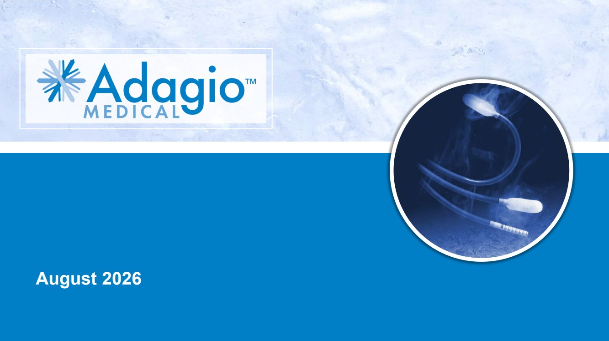 | 1 August 2026
 | 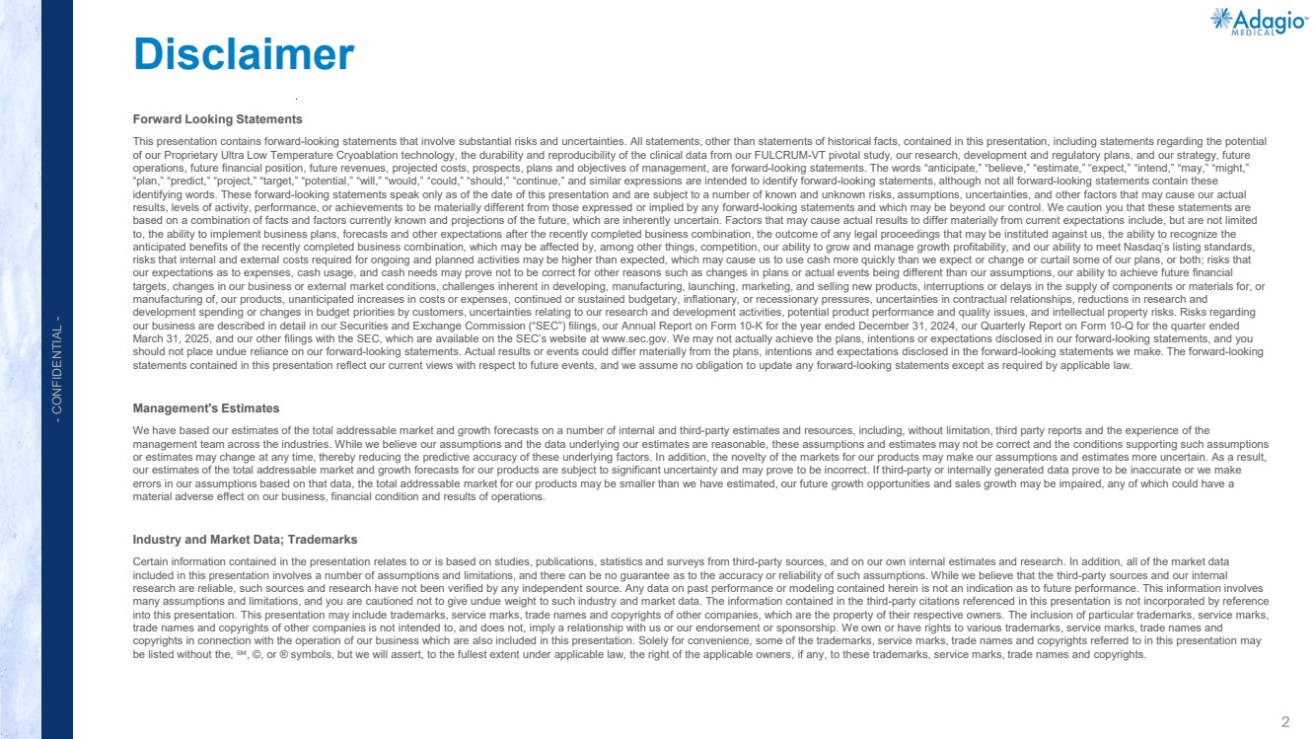 | 2 - CONFIDENTIAL - Forward Looking Statements This presentation contains forward-looking statements that involve substantial risks and uncertainties. All statements, other than statements of historical facts, contained in this presentation, including statements regarding the potential of our Proprietary Ultra Low Temperature Cryoablation technology, the durability and reproducibility of the clinical data from our FULCRUM-VT pivotal study, our research, development and regulatory plans, and our strategy, future operations, future financial position, future revenues, projected costs, prospects, plans and objectives of management, are forward-looking statements. The words “anticipate,” “believe,” “estimate,” “expect,” “intend,” “may,” “might,” “plan,” “predict,” “project,” “target,” “potential,” “will,” “would,” “could,” “should,” “continue,” and similar expressions are intended to identify forward-looking statements, although not all forward-looking statements contain these identifying words. These forward-looking statements speak only as of the date of this presentation and are subject to a number of known and unknown risks, assumptions, uncertainties, and other factors that may cause our actual results, levels of activity, performance, or achievements to be materially different from those expressed or implied by any forward-looking statements and which may be beyond our control. We caution you that these statements are based on a combination of facts and factors currently known and projections of the future, which are inherently uncertain. Factors that may cause actual results to differ materially from current expectations include, but are not limited to, the ability to implement business plans, forecasts and other expectations after the recently completed business combination, the outcome of any legal proceedings that may be instituted against us, the ability to recognize the anticipated benefits of the recently completed business combination, which may be affected by, among other things, competition, our ability to grow and manage growth profitability, and our ability to meet Nasdaq’s listing standards, risks that internal and external costs required for ongoing and planned activities may be higher than expected, which may cause us to use cash more quickly than we expect or change or curtail some of our plans, or both; risks that our expectations as to expenses, cash usage, and cash needs may prove not to be correct for other reasons such as changes in plans or actual events being different than our assumptions, our ability to achieve future financial targets, changes in our business or external market conditions, challenges inherent in developing, manufacturing, launching, marketing, and selling new products, interruptions or delays in the supply of components or materials for, or manufacturing of, our products, unanticipated increases in costs or expenses, continued or sustained budgetary, inflationary, or recessionary pressures, uncertainties in contractual relationships, reductions in research and development spending or changes in budget priorities by customers, uncertainties relating to our research and development activities, potential product performance and quality issues, and intellectual property risks. Risks regarding our business are described in detail in our Securities and Exchange Commission (“SEC”) filings, our Annual Report on Form 10-K for the year ended December 31, 2024, our Quarterly Report on Form 10-Q for the quarter ended March 31, 2025, and our other filings with the SEC, which are available on the SEC’s website at www.sec.gov. We may not actually achieve the plans, intentions or expectations disclosed in our forward-looking statements, and you should not place undue reliance on our forward-looking statements. Actual results or events could differ materially from the plans, intentions and expectations disclosed in the forward-looking statements we make. The forward-looking statements contained in this presentation reflect our current views with respect to future events, and we assume no obligation to update any forward-looking statements except as required by applicable law. Management's Estimates We have based our estimates of the total addressable market and growth forecasts on a number of internal and third-party estimates and resources, including, without limitation, third party reports and the experience of the management team across the industries. While we believe our assumptions and the data underlying our estimates are reasonable, these assumptions and estimates may not be correct and the conditions supporting such assumptions or estimates may change at any time, thereby reducing the predictive accuracy of these underlying factors. In addition, the novelty of the markets for our products may make our assumptions and estimates more uncertain. As a result, our estimates of the total addressable market and growth forecasts for our products are subject to significant uncertainty and may prove to be incorrect. If third-party or internally generated data prove to be inaccurate or we make errors in our assumptions based on that data, the total addressable market for our products may be smaller than we have estimated, our future growth opportunities and sales growth may be impaired, any of which could have a material adverse effect on our business, financial condition and results of operations. Industry and Market Data; Trademarks Certain information contained in the presentation relates to or is based on studies, publications, statistics and surveys from third-party sources, and on our own internal estimates and research. In addition, all of the market data included in this presentation involves a number of assumptions and limitations, and there can be no guarantee as to the accuracy or reliability of such assumptions. While we believe that the third-party sources and our internal research are reliable, such sources and research have not been verified by any independent source. Any data on past performance or modeling contained herein is not an indication as to future performance. This information involves many assumptions and limitations, and you are cautioned not to give undue weight to such industry and market data. The information contained in the third-party citations referenced in this presentation is not incorporated by reference into this presentation. This presentation may include trademarks, service marks, trade names and copyrights of other companies, which are the property of their respective owners. The inclusion of particular trademarks, service marks, trade names and copyrights of other companies is not intended to, and does not, imply a relationship with us or our endorsement or sponsorship. We own or have rights to various trademarks, service marks, trade names and copyrights in connection with the operation of our business which are also included in this presentation. Solely for convenience, some of the trademarks, service marks, trade names and copyrights referred to in this presentation may be listed without the, ℠, ©, or ® symbols, but we will assert, to the fullest extent under applicable law, the right of the applicable owners, if any, to these trademarks, service marks, trade names and copyrights. Disclaimer
 | 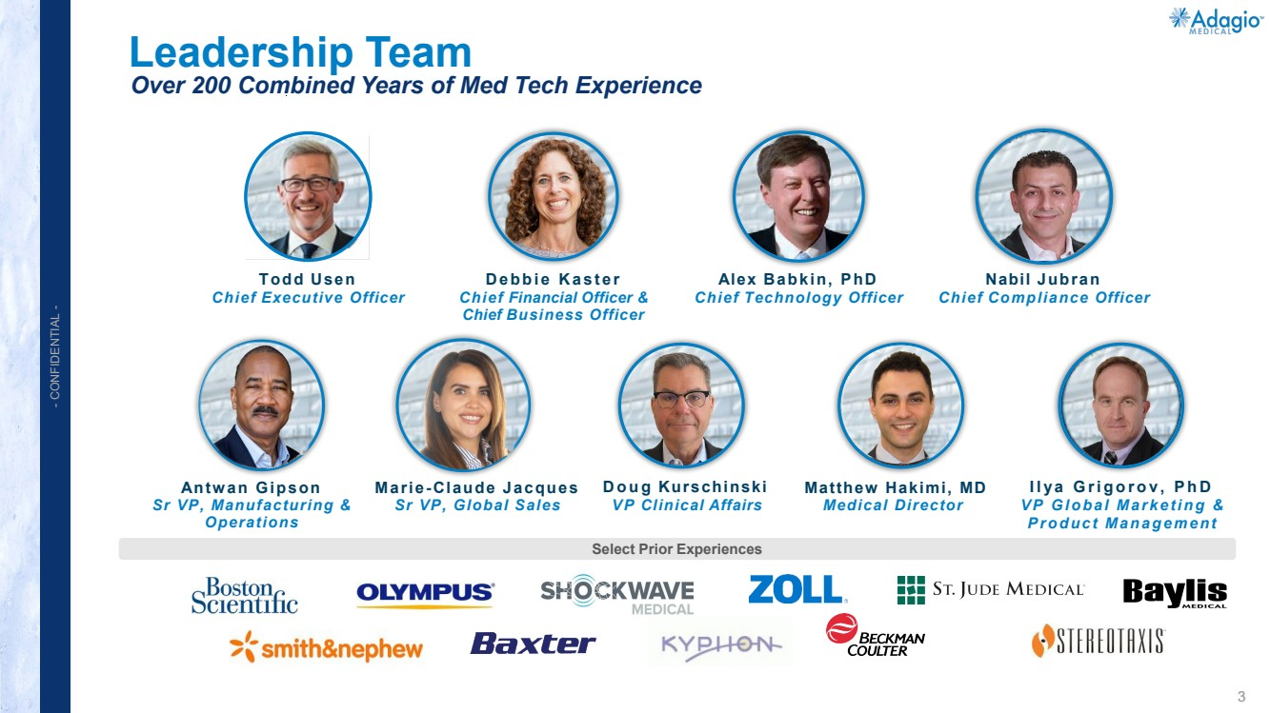 | 3 - CONFIDENTIAL - Leadership Team Over 200 Combined Years of Med Tech Experience Select Prior Experiences Doug Kurschinski VP Clinical Affairs Ilya Grigorov, PhD VP Global Marketing & Product Management Matthew Hakimi, MD Medical Director Marie-Claude Jacques Sr VP, Global Sales Antwan Gipson Sr VP, Manufacturing & Operations Todd Usen Chief Executive Officer Debbie Kaster Chief Financial Officer & Chief Business Officer Nabil Jubran Chief Compliance Officer Alex Babkin, PhD Chief Technology Officer
 | 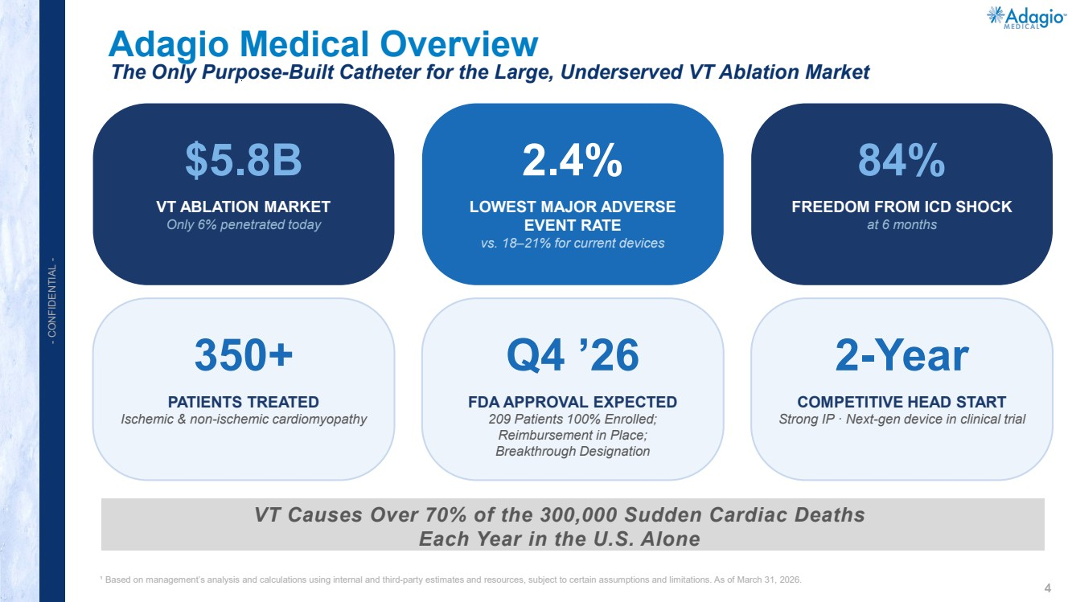 | 4 - CONFIDENTIAL - Adagio Medical Overview ¹ Based on management’s analysis and calculations using internal and third-party estimates and resources, subject to certain assumptions and limitations. As of March 31, 2026. The Only Purpose-Built Catheter for the Large, Underserved VT Ablation Market VT Causes Over 70% of the 300,000 Sudden Cardiac Deaths Each Year in the U.S. Alone $5.8B VT ABLATION MARKET Only 6% penetrated today 2.4% LOWEST MAJOR ADVERSE EVENT RATE vs. 18–21% for current devices 84% FREEDOM FROM ICD SHOCK at 6 months 350+ PATIENTS TREATED Ischemic & non-ischemic cardiomyopathy Q4 ’26 FDA APPROVAL EXPECTED 209 Patients 100% Enrolled; Reimbursement in Place; Breakthrough Designation 2-Year COMPETITIVE HEAD START Strong IP · Next-gen device in clinical trial
 | 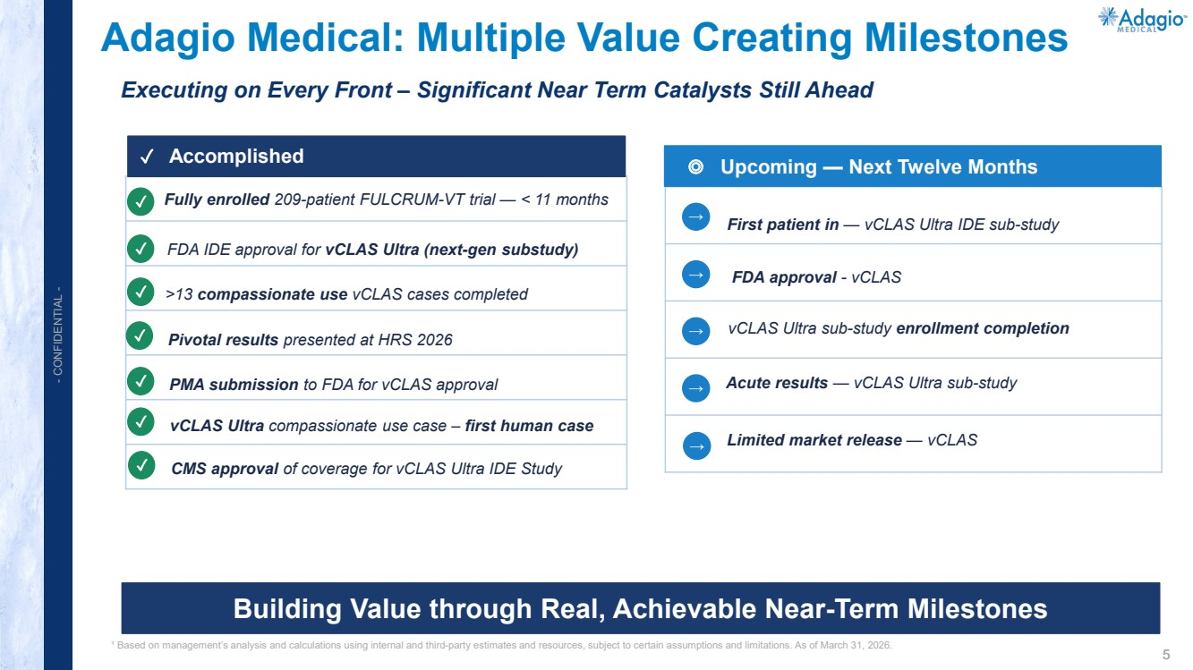 | 5 - CONFIDENTIAL - FDA IDE approval for vCLAS Ultra (next-gen substudy) Fully enrolled 209-patient FULCRUM-VT trial — < 11 months >13 compassionate use vCLAS cases completed Pivotal results presented at HRS 2026 ¹ Based on management’s analysis and calculations using internal and third-party estimates and resources, subject to certain assumptions and limitations. As of March 31, 2026. ✓ Accomplished ◎ Upcoming — Next Twelve Months Building Value through Real, Achievable Near-Term Milestones Adagio Medical: Multiple Value Creating Milestones Executing on Every Front – Significant Near Term Catalysts Still Ahead ✓ ✓ ✓ ✓ ✓ PMA submission to FDA for vCLAS approval vCLAS Ultra sub-study enrollment completion First patient in — vCLAS Ultra IDE sub-study Acute results — vCLAS Ultra sub-study → → → → FDA approval - vCLAS → → Limited market release — vCLAS vCLAS Ultra compassionate use case – first human case ✓ ✓ CMS approval of coverage for vCLAS Ultra IDE Study
 | 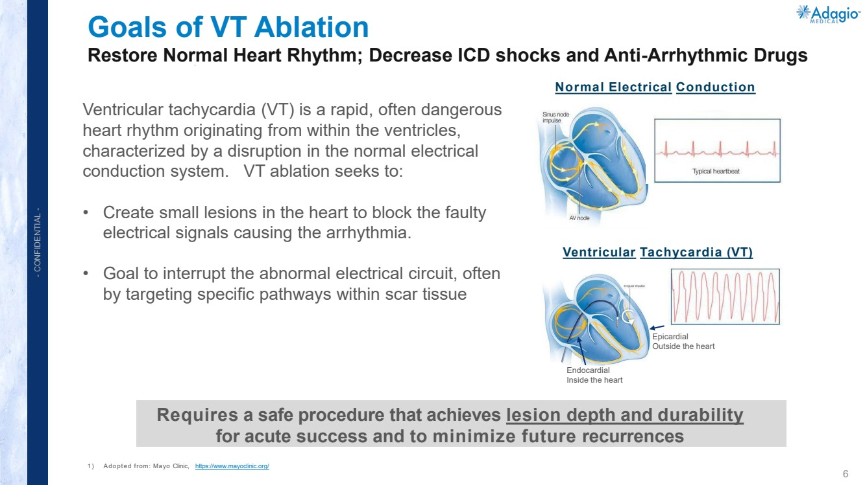 | 6 - CONFIDENTIAL - Goals of VT Ablation Restore Normal Heart Rhythm; Decrease ICD shocks and Anti-Arrhythmic Drugs 1) Adopted from: Mayo Clinic, https://www.mayoclinic.org/ Normal Electrical Conduction Ventricular Tachycardia (VT) Requires a safe procedure that achieves lesion depth and durability for acute success and to minimize future recurrences Ventricular tachycardia (VT) is a rapid, often dangerous heart rhythm originating from within the ventricles, characterized by a disruption in the normal electrical conduction system. VT ablation seeks to: • Create small lesions in the heart to block the faulty electrical signals causing the arrhythmia. • Goal to interrupt the abnormal electrical circuit, often by targeting specific pathways within scar tissue Epicardial Outside the heart Endocardial Inside the heart
 | 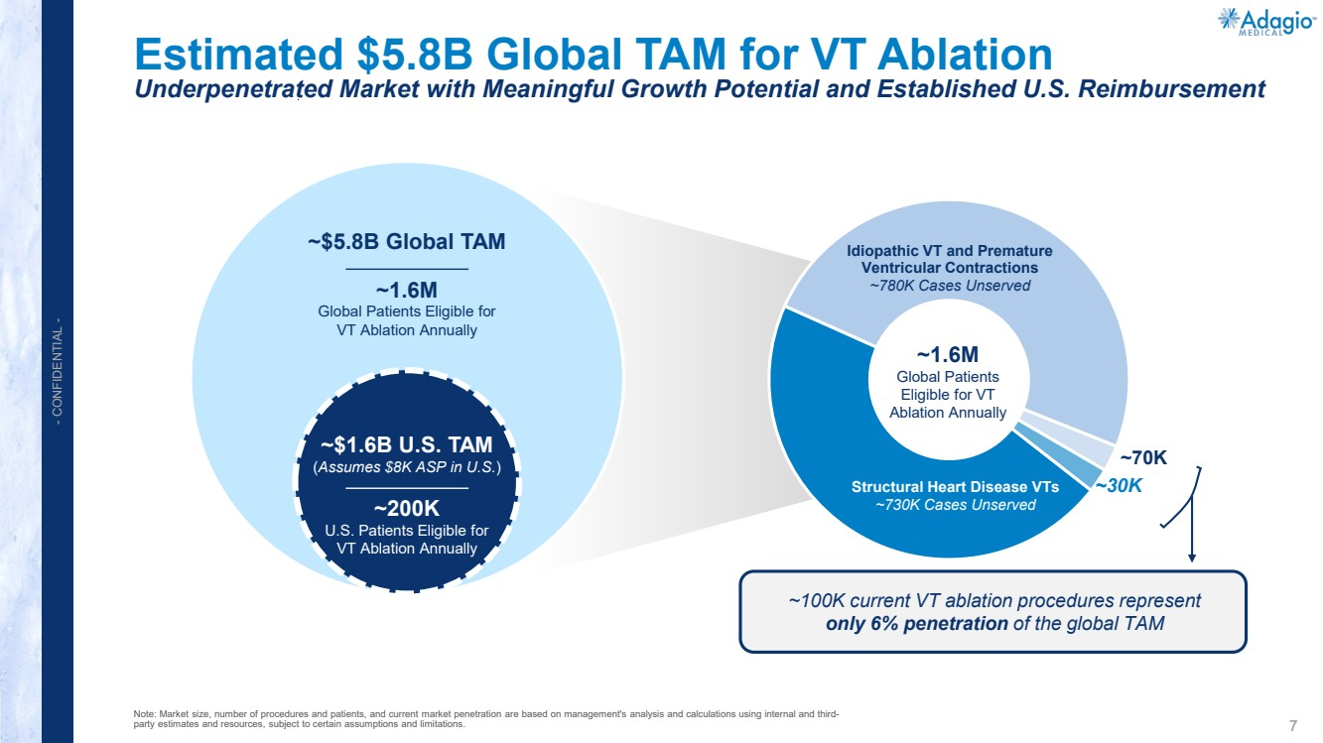 | 7 - CONFIDENTIAL - Estimated $5.8B Global TAM for VT Ablation Underpenetrated Market with Meaningful Growth Potential and Established U.S. Reimbursement Note: Market size, number of procedures and patients, and current market penetration are based on management's analysis and calculations using internal and third-party estimates and resources, subject to certain assumptions and limitations. ~1.6M Global Patients Eligible for VT Ablation Annually ~200K U.S. Patients Eligible for VT Ablation Annually Structural Heart Disease VTs ~730K Cases Unserved Idiopathic VT and Premature Ventricular Contractions ~780K Cases Unserved ~70K ~30K ~$5.8B Global TAM ~$1.6B U.S. TAM (Assumes $8K ASP in U.S.) ~100K current VT ablation procedures represent only 6% penetration of the global TAM ~1.6M Global Patients Eligible for VT Ablation Annually
 | 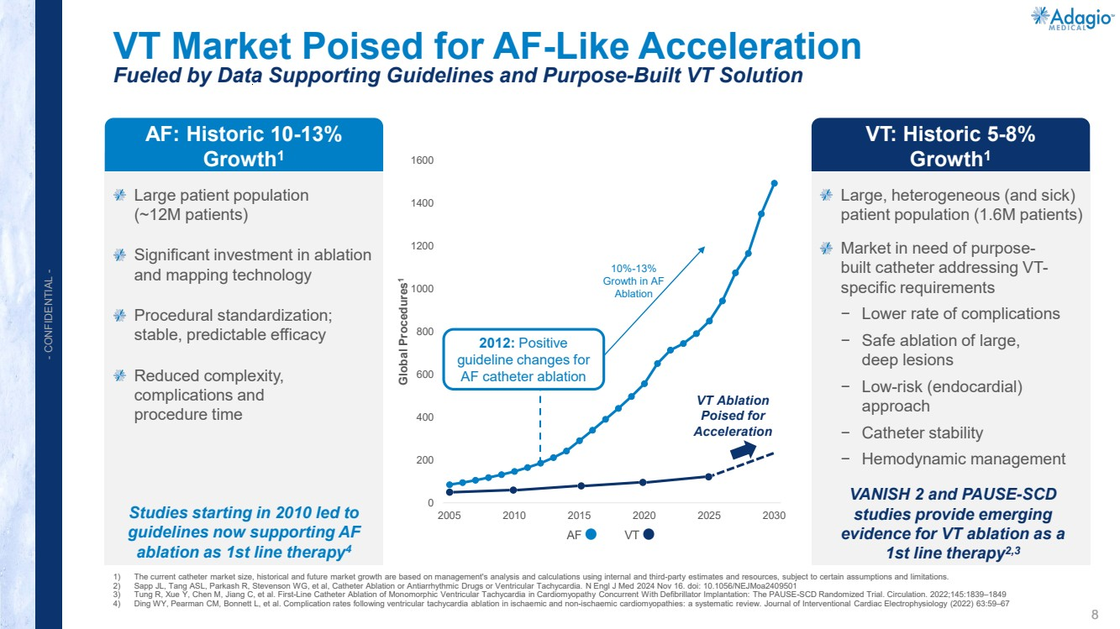 | 8 - CONFIDENTIAL - 0 200 400 600 800 1000 1200 1400 1600 2005 2010 2015 2020 2025 2030 Global Procedures1 VT Market Poised for AF-Like Acceleration Fueled by Data Supporting Guidelines and Purpose-Built VT Solution 1) The current catheter market size, historical and future market growth are based on management's analysis and calculations using internal and third-party estimates and resources, subject to certain assumptions and limitations. 2) Sapp JL, Tang ASL, Parkash R, Stevenson WG, et al, Catheter Ablation or Antiarrhythmic Drugs or Ventricular Tachycardia. N Engl J Med 2024 Nov 16. doi: 10.1056/NEJMoa2409501 3) Tung R, Xue Y, Chen M, Jiang C, et al. First-Line Catheter Ablation of Monomorphic Ventricular Tachycardia in Cardiomyopathy Concurrent With Defibrillator Implantation: The PAUSE-SCD Randomized Trial. Circulation. 2022;145:1839–1849 4) Ding WY, Pearman CM, Bonnett L, et al. Complication rates following ventricular tachycardia ablation in ischaemic and non-ischaemic cardiomyopathies: a systematic review. Journal of Interventional Cardiac Electrophysiology (2022) 63:59–67 Large patient population (~12M patients) Significant investment in ablation and mapping technology Procedural standardization; stable, predictable efficacy Reduced complexity, complications and procedure time Large, heterogeneous (and sick) patient population (1.6M patients) Market in need of purpose-built catheter addressing VT-specific requirements − Lower rate of complications − Safe ablation of large, deep lesions − Low-risk (endocardial) approach − Catheter stability − Hemodynamic management AF: Historic 10-13% Growth1 VT: Historic 5-8% Growth1 2012: Positive guideline changes for AF catheter ablation VT Ablation Poised for Acceleration VANISH 2 and PAUSE-SCD studies provide emerging evidence for VT ablation as a 1st line therapy2,3 Studies starting in 2010 led to guidelines now supporting AF ablation as 1st line therapy4 10%-13% Growth in AF Ablation
 | 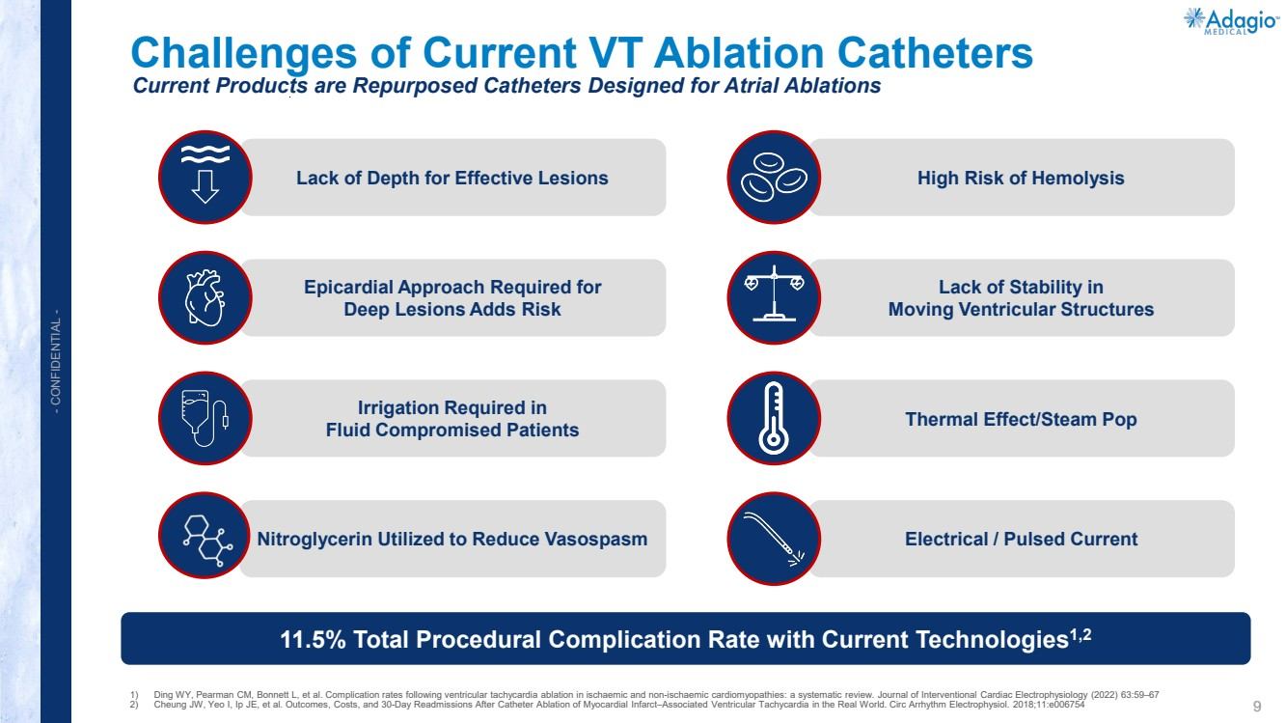 | 9 - CONFIDENTIAL - 11.5% Total Procedural Complication Rate with Current Technologies1,2 Nitroglycerin Utilized to Reduce Vasospasm Irrigation Required in Fluid Compromised Patients High Risk of Hemolysis Thermal Effect/Steam Pop Electrical / Pulsed Current Epicardial Approach Required for Deep Lesions Adds Risk 1) Ding WY, Pearman CM, Bonnett L, et al. Complication rates following ventricular tachycardia ablation in ischaemic and non-ischaemic cardiomyopathies: a systematic review. Journal of Interventional Cardiac Electrophysiology (2022) 63:59–67 2) Cheung JW, Yeo I, Ip JE, et al. Outcomes, Costs, and 30-Day Readmissions After Catheter Ablation of Myocardial Infarct–Associated Ventricular Tachycardia in the Real World. Circ Arrhythm Electrophysiol. 2018;11:e006754 Lack of Depth for Effective Lesions Lack of Stability in Moving Ventricular Structures Current Products are Repurposed Catheters Designed for Atrial Ablations Challenges of Current VT Ablation Catheters
 | 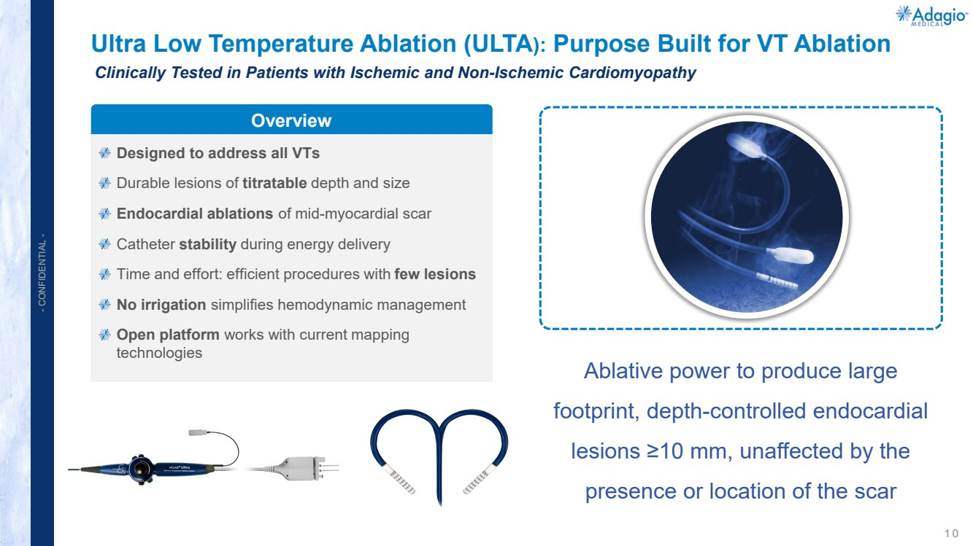 | 1 0 - CONFIDENTIAL - Ultra Low Temperature Ablation (ULTA): Purpose Built for VT Ablation Clinically Tested in Patients with Ischemic and Non-Ischemic Cardiomyopathy Designed to address all VTs Durable lesions of titratable depth and size Endocardial ablations of mid-myocardial scar Catheter stability during energy delivery Time and effort: efficient procedures with few lesions No irrigation simplifies hemodynamic management Open platform works with current mapping technologies Overview Ablative power to produce large footprint, depth-controlled endocardial lesions ≥10 mm, unaffected by the presence or location of the scar
 | 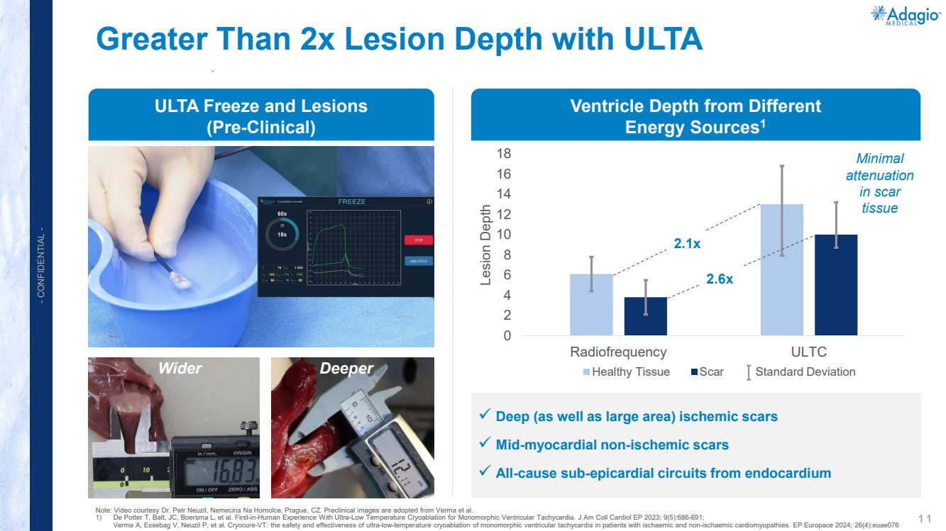 | 1 1 - CONFIDENTIAL - Greater Than 2x Lesion Depth with ULTA Note: Video courtesy Dr. Petr Neuzil, Nemecina Na Homolce, Prague, CZ. Preclinical images are adopted from Verma et al. 1) De Potter T, Balt, JC, Boersma L, et al. First-in-Human Experience With Ultra-Low Temperature Cryoablation for Monomorphic Ventricular Tachycardia. J Am Coll Cardiol EP 2023; 9(5):686-691; Verma A, Essebag V, Neuzil P, et al. Cryocure-VT: the safety and effectiveness of ultra-low-temperature cryoablation of monomorphic ventricular tachycardia in patients with ischaemic and non-ischaemic cardiomyopathies. EP Europace 2024; 26(4):euae076 0 2 4 6 8 10 12 14 16 18 Radiofrequency ULTC Lesion Depth Healthy Tissue Scar Deep (as well as large area) ischemic scars Mid-myocardial non-ischemic scars All-cause sub-epicardial circuits from endocardium 2.1x 2.6x Minimal attenuation in scar tissue Standard Deviation Ventricle Depth from Different Energy Sources1 ULTA Freeze and Lesions (Pre-Clinical) Wider Deeper
 | 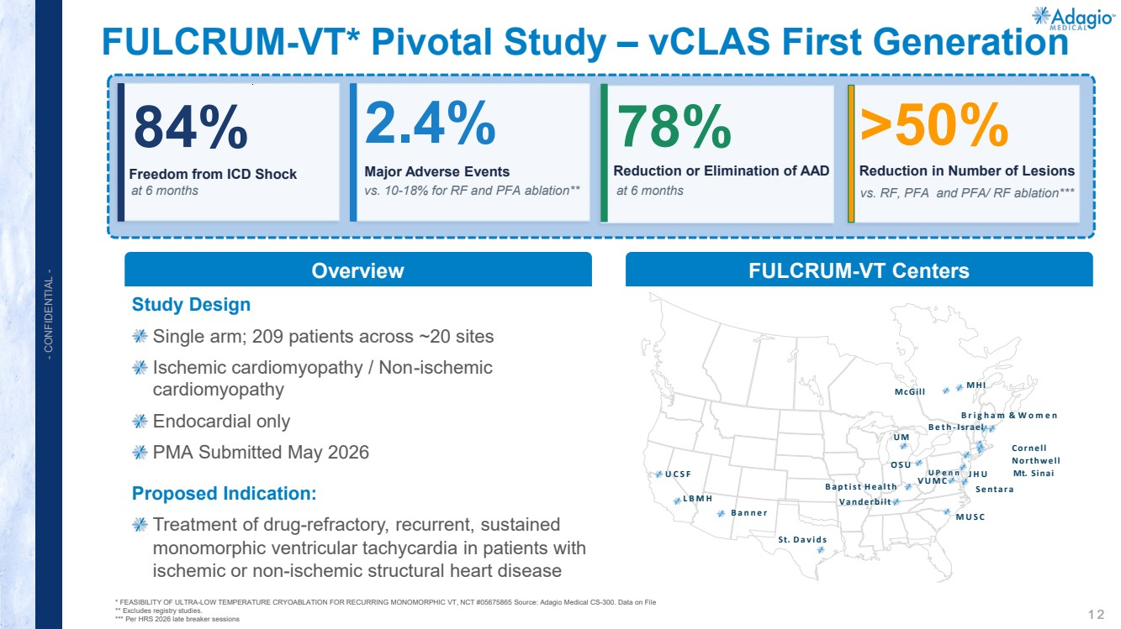 | 1 2 - CONFIDENTIAL - Study Design Single arm; 209 patients across ~20 sites Ischemic cardiomyopathy / Non-ischemic cardiomyopathy Endocardial only PMA Submitted May 2026 Proposed Indication: Treatment of drug-refractory, recurrent, sustained monomorphic ventricular tachycardia in patients with ischemic or non-ischemic structural heart disease FULCRUM-VT* Pivotal Study – vCLAS First Generation * FEASIBILITY OF ULTRA-LOW TEMPERATURE CRYOABLATION FOR RECURRING MONOMORPHIC VT, NCT #05675865 Source: Adagio Medical CS-300. Data on File ** Excludes registry studies. *** Per HRS 2026 late breaker sessions Overview UCSF LBMH Banner St. Davids MUSC VUMC OSU U M JHU Sentara Brigham & Women Beth - Israel Cornell Northwell UPenn Mt. Sinai McGill MHI Baptist Health Vanderbilt FULCRUM-VT Centers 84% Freedom from ICD Shock at 6 months 2.4% Major Adverse Events vs. 10-18% for RF and PFA ablation** >50% Reduction in Number of Lesions 78% Reduction or Elimination of AAD at 6 months vs. RF, PFA and PFA/ RF ablation***
 | 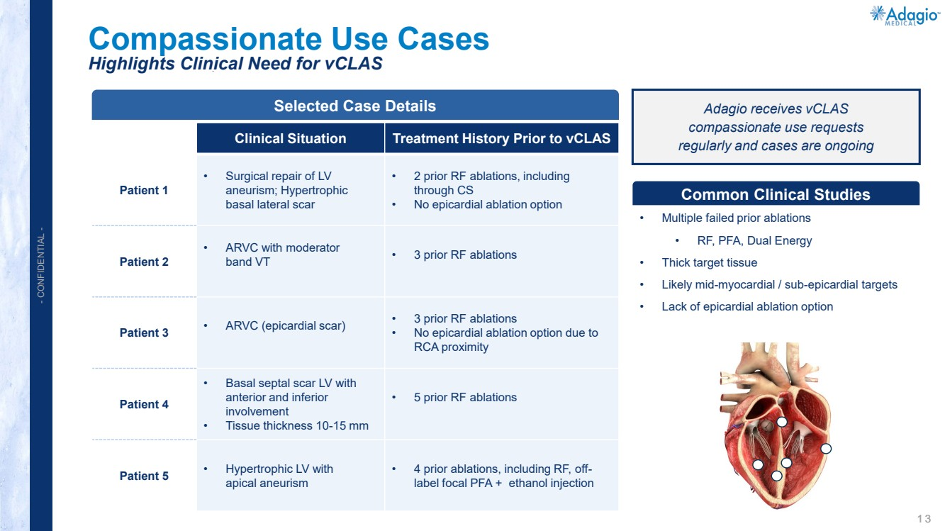 | 1 3 - CONFIDENTIAL - Common Clinical Studies Selected Case Details Compassionate Use Cases Highlights Clinical Need for vCLAS Clinical Situation Treatment History Prior to vCLAS Patient 1 • Surgical repair of LV aneurism; Hypertrophic basal lateral scar • 2 prior RF ablations, including through CS • No epicardial ablation option Patient 2 • ARVC with moderator band VT • 3 prior RF ablations Patient 3 • ARVC (epicardial scar) • 3 prior RF ablations • No epicardial ablation option due to RCA proximity Patient 4 • Basal septal scar LV with anterior and inferior involvement • Tissue thickness 10-15 mm • 5 prior RF ablations Patient 5 • Hypertrophic LV with apical aneurism • 4 prior ablations, including RF, off-label focal PFA + ethanol injection • Multiple failed prior ablations • RF, PFA, Dual Energy • Thick target tissue • Likely mid-myocardial / sub-epicardial targets • Lack of epicardial ablation option Adagio receives vCLAS compassionate use requests regularly and cases are ongoing
 | 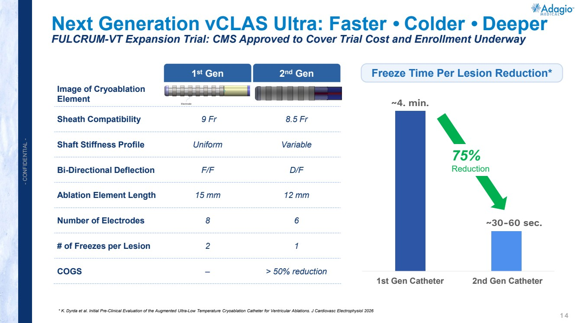 | 1 4 - CONFIDENTIAL - Next Generation vCLAS Ultra: Faster • Colder • Deeper FULCRUM-VT Expansion Trial: CMS Approved to Cover Trial Cost and Enrollment Underway * K. Dyrda et al. Initial Pre-Clinical Evaluation of the Augmented Ultra-Low Temperature Cryoablation Catheter for Ventricular Ablations. J Cardiovasc Electrophysiol 2026 ~4. min. ~30-60 sec. 1st Gen Catheter 2nd Gen Catheter 75% Reduction Image of Cryoablation Element Sheath Compatibility 9 Fr 8.5 Fr Shaft Stiffness Profile Uniform Variable Bi-Directional Deflection F/F D/F Ablation Element Length 15 mm 12 mm Number of Electrodes 8 6 # of Freezes per Lesion 2 1 COGS – > 50% reduction 1st Gen 2nd Gen Freeze Time Per Lesion Reduction*
 | 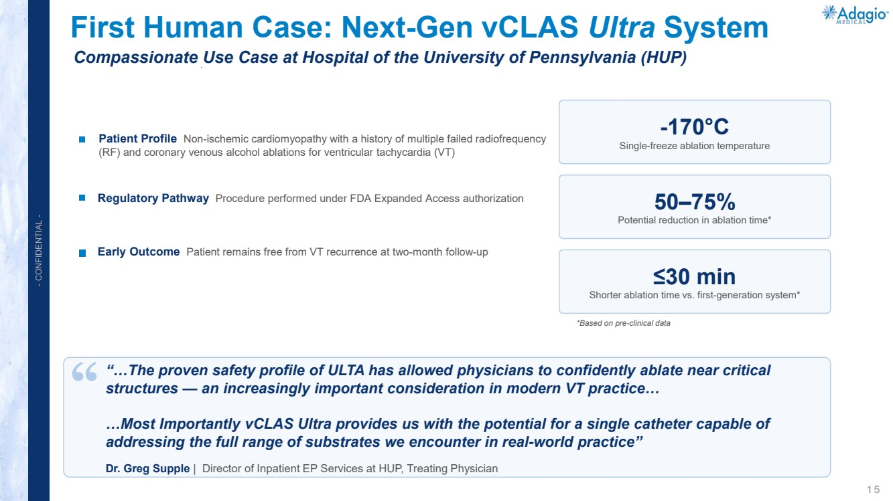 | 1 5 - CONFIDENTIAL - First Human Case: Next-Gen vCLAS Ultra System Patient Profile Non-ischemic cardiomyopathy with a history of multiple failed radiofrequency (RF) and coronary venous alcohol ablations for ventricular tachycardia (VT) Regulatory Pathway Procedure performed under FDA Expanded Access authorization Early Outcome Patient remains free from VT recurrence at two-month follow-up -170°C Single-freeze ablation temperature 50–75% Potential reduction in ablation time* ≤30 min Shorter ablation time vs. first-generation system* *Based on pre-clinical data ““…The proven safety profile of ULTA has allowed physicians to confidently ablate near critical structures — an increasingly important consideration in modern VT practice… …Most Importantly vCLAS Ultra provides us with the potential for a single catheter capable of addressing the full range of substrates we encounter in real-world practice” Dr. Greg Supple | Director of Inpatient EP Services at HUP, Treating Physician Compassionate Use Case at Hospital of the University of Pennsylvania (HUP)
 | 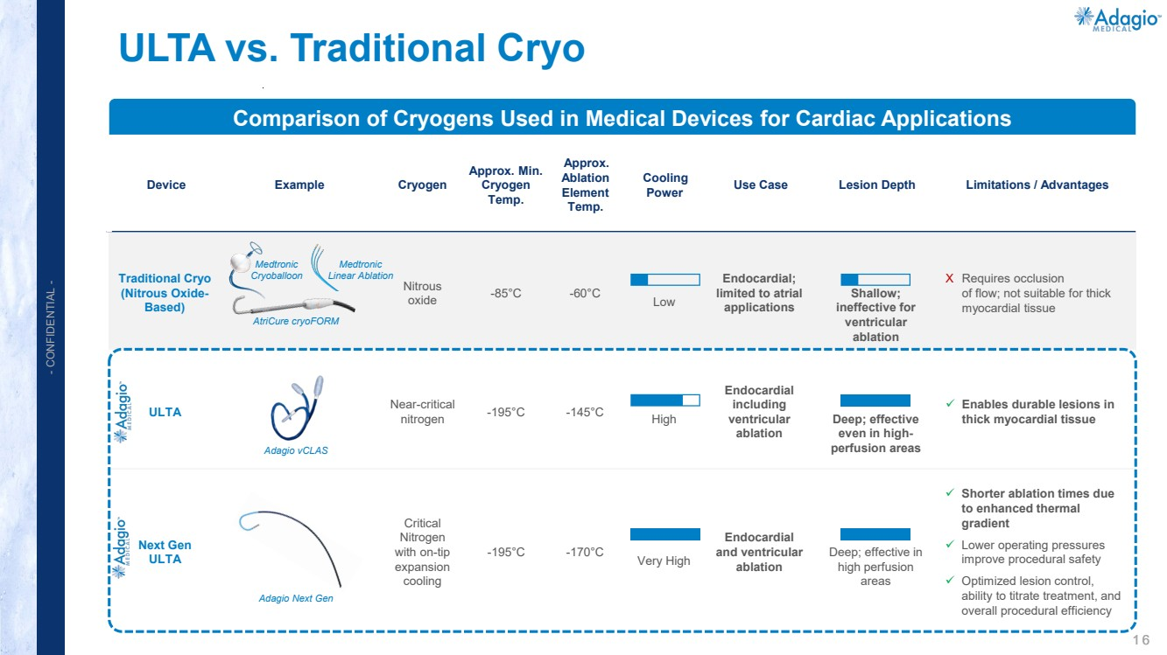 | 1 6 - CONFIDENTIAL - ULTA vs. Traditional Cryo Device Example Cryogen Approx. Min. Cryogen Temp. Approx. Ablation Element Temp. Cooling Power Use Case Lesion Depth Limitations / Advantages Traditional Cryo (Nitrous Oxide-Based) Nitrous oxide -85°C -60°C Low Endocardial; limited to atrial applications Shallow; ineffective for ventricular ablation X Requires occlusion of flow; not suitable for thick myocardial tissue ULTA Near-critical nitrogen -195°C -145°C High Endocardial including ventricular ablation Deep; effective even in high-perfusion areas Enables durable lesions in thick myocardial tissue Next Gen ULTA Critical Nitrogen with on-tip expansion cooling -195°C -170°C Very High Endocardial and ventricular ablation Deep; effective in high perfusion areas Shorter ablation times due to enhanced thermal gradient Lower operating pressures improve procedural safety Optimized lesion control, ability to titrate treatment, and overall procedural efficiency Comparison of Cryogens Used in Medical Devices for Cardiac Applications Medtronic Cryoballoon Medtronic Linear Ablation AtriCure cryoFORM Adagio vCLAS Adagio Next Gen
 | 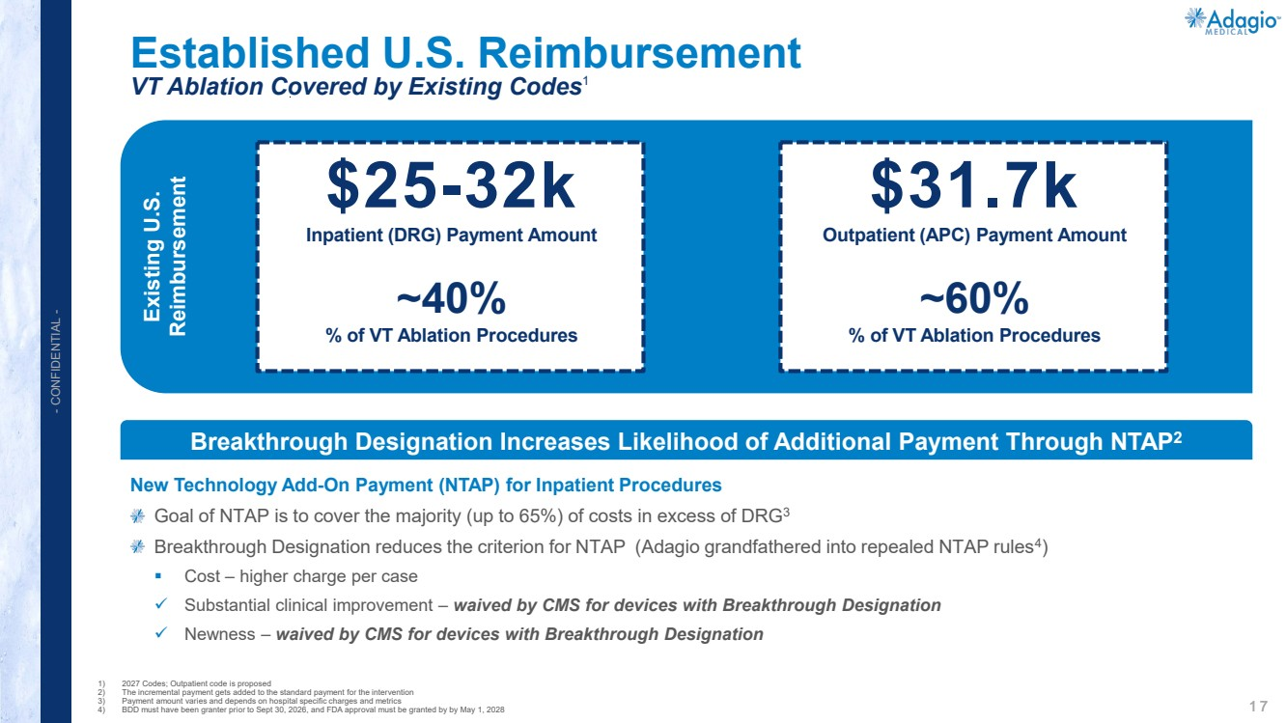 | 1 7 - CONFIDENTIAL - Established U.S. Reimbursement VT Ablation Covered by Existing Codes1 1) 2027 Codes; Outpatient code is proposed 2) The incremental payment gets added to the standard payment for the intervention 3) Payment amount varies and depends on hospital specific charges and metrics 4) BDD must have been granter prior to Sept 30, 2026, and FDA approval must be granted by by May 1, 2028 Existing U.S. Reimbursement $25-32k Inpatient (DRG) Payment Amount ~40% % of VT Ablation Procedures $31.7k Outpatient (APC) Payment Amount ~60% % of VT Ablation Procedures Breakthrough Designation Increases Likelihood of Additional Payment Through NTAP2 New Technology Add-On Payment (NTAP) for Inpatient Procedures Goal of NTAP is to cover the majority (up to 65%) of costs in excess of DRG3 Breakthrough Designation reduces the criterion for NTAP (Adagio grandfathered into repealed NTAP rules4) Cost – higher charge per case Substantial clinical improvement – waived by CMS for devices with Breakthrough Designation Newness – waived by CMS for devices with Breakthrough Designation
 | 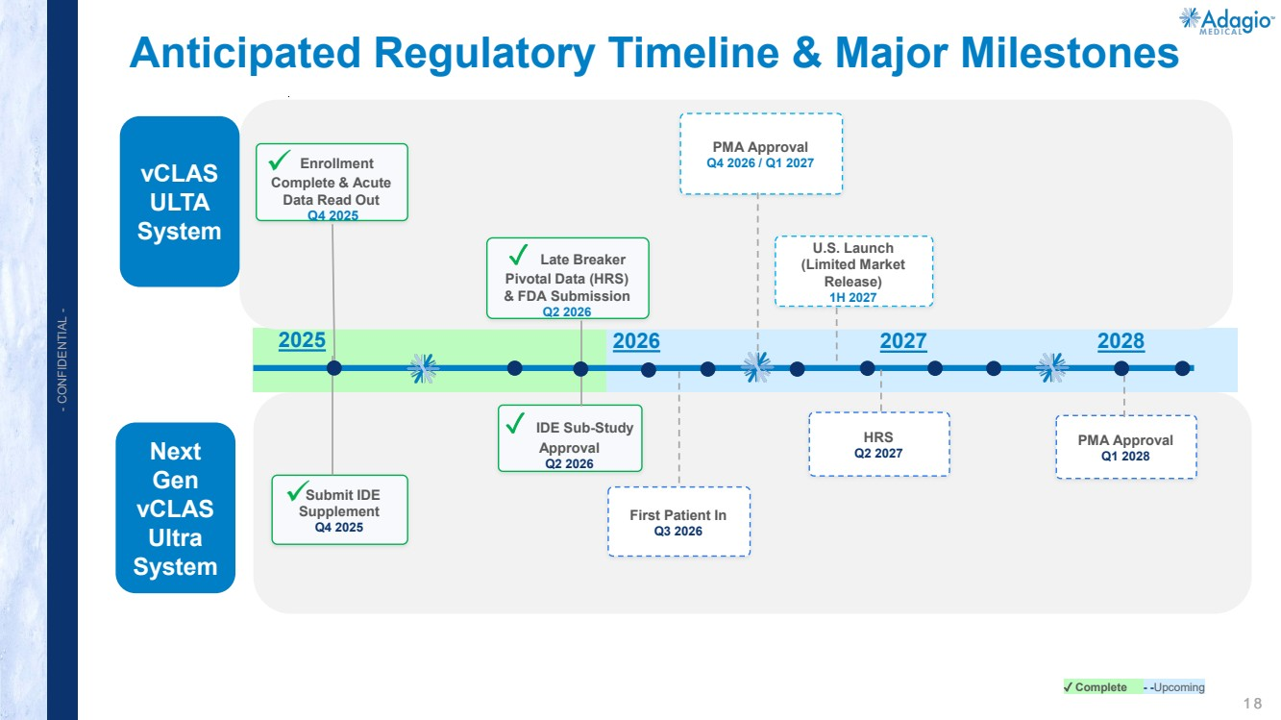 | 1 8 - CONFIDENTIAL - Anticipated Regulatory Timeline & Major Milestones Next Gen vCLAS Ultra System vCLAS ULTA System Enrollment Complete & Acute Data Read Out Q4 2025 ✓ Late Breaker Pivotal Data (HRS) & FDA Submission Q2 2026 PMA Approval Q4 2026 / Q1 2027 U.S. Launch (Limited Market Release) 1H 2027 Submit IDE Supplement Q4 2025 ✓ IDE Sub-Study Approval Q2 2026 First Patient In Q3 2026 HRS Q2 2027 PMA Approval Q1 2028 ✓ Complete - -Upcoming 2025 2026 2027 2028
 | 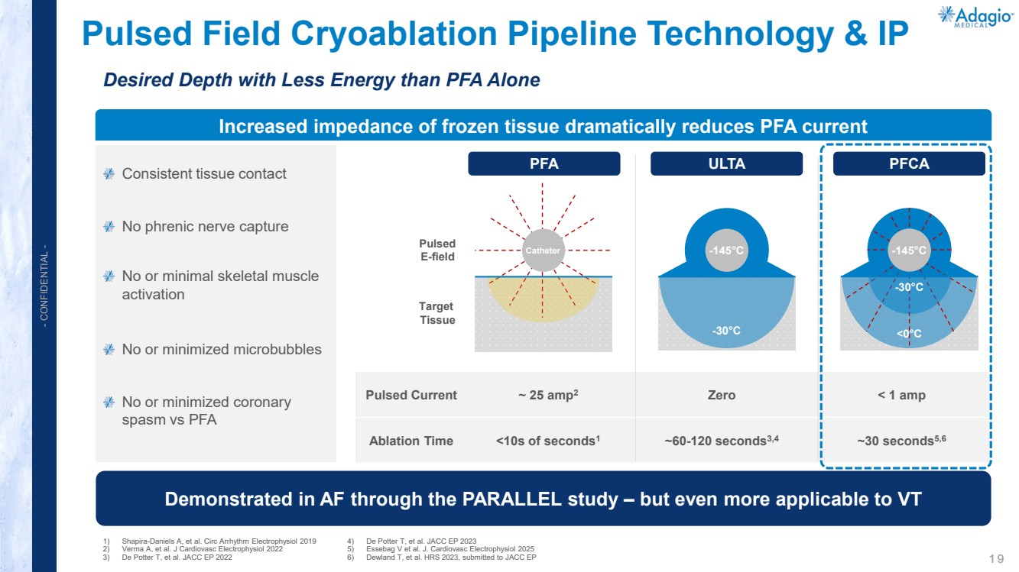 | 1 9 - CONFIDENTIAL - Pulsed Current ~ 25 amp2 Zero < 1 amp Ablation Time <10s of seconds1 ~60-120 seconds3,4 ~30 seconds5,6 Pulsed Field Cryoablation Pipeline Technology & IP Desired Depth with Less Energy than PFA Alone 1) Shapira-Daniels A, et al. Circ Arrhythm Electrophysiol 2019 2) Verma A, et al. J Cardiovasc Electrophysiol 2022 3) De Potter T, et al. JACC EP 2022 4) De Potter T, et al. JACC EP 2023 5) Essebag V et al. J. Cardiovasc Electrophysiol 2025 6) Dewland T, et al. HRS 2023, submitted to JACC EP Increased impedance of frozen tissue dramatically reduces PFA current Demonstrated in AF through the PARALLEL study – but even more applicable to VT PFA ULTA PFCA Catheter Pulsed E-field Target Tissue -30°C -145°C -145°C <0°C -30°C Consistent tissue contact No phrenic nerve capture No or minimal skeletal muscle activation No or minimized microbubbles No or minimized coronary spasm vs PFA
 | 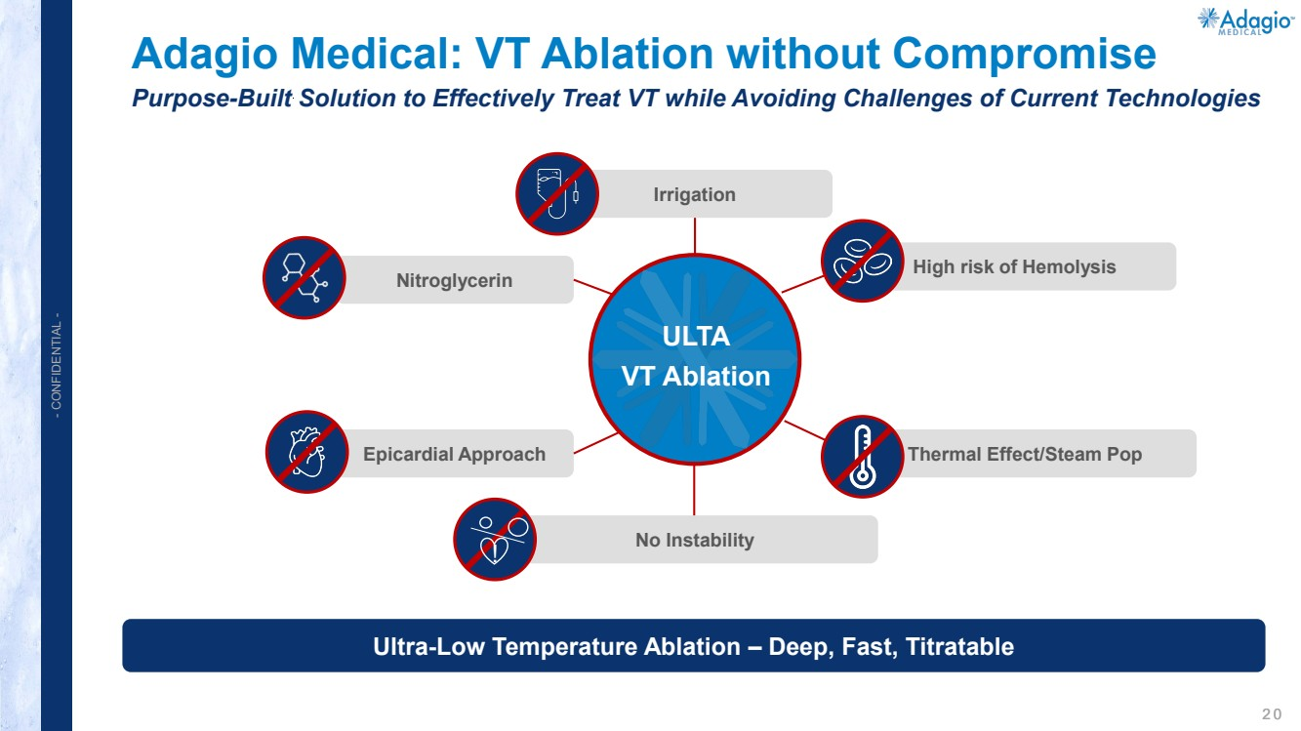 | 2 0 - CONFIDENTIAL - Adagio Medical: VT Ablation without Compromise Purpose-Built Solution to Effectively Treat VT while Avoiding Challenges of Current Technologies Ultra-Low Temperature Ablation – Deep, Fast, Titratable Nitroglycerin Irrigation High risk of Hemolysis Epicardial Approach No Instability Thermal Effect/Steam Pop ULTA VT Ablation !
 | 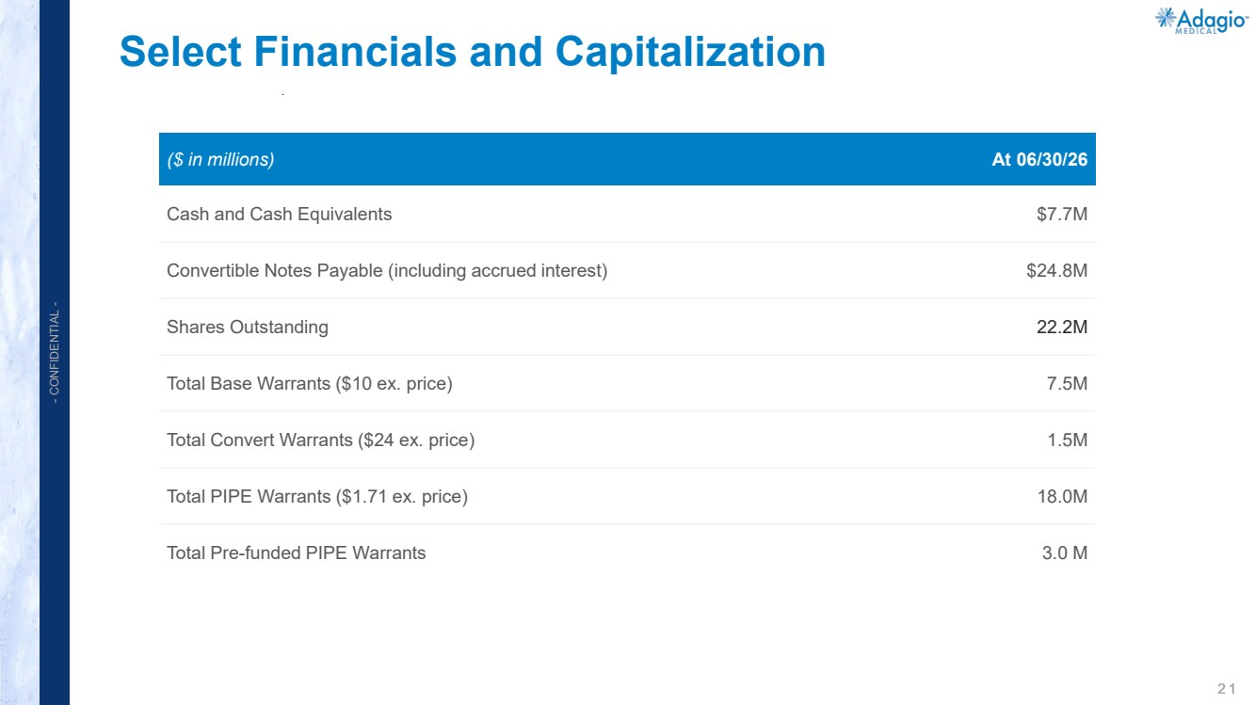 | 2 1 - CONFIDENTIAL - Select Financials and Capitalization ($ in millions) At 06/30/26 Cash and Cash Equivalents $7.7M Convertible Notes Payable (including accrued interest) $24.8M Shares Outstanding 22.2M Total Base Warrants ($10 ex. price) 7.5M Total Convert Warrants ($24 ex. price) 1.5M Total PIPE Warrants ($1.71 ex. price) 18.0M Total Pre-funded PIPE Warrants 3.0 M
 | 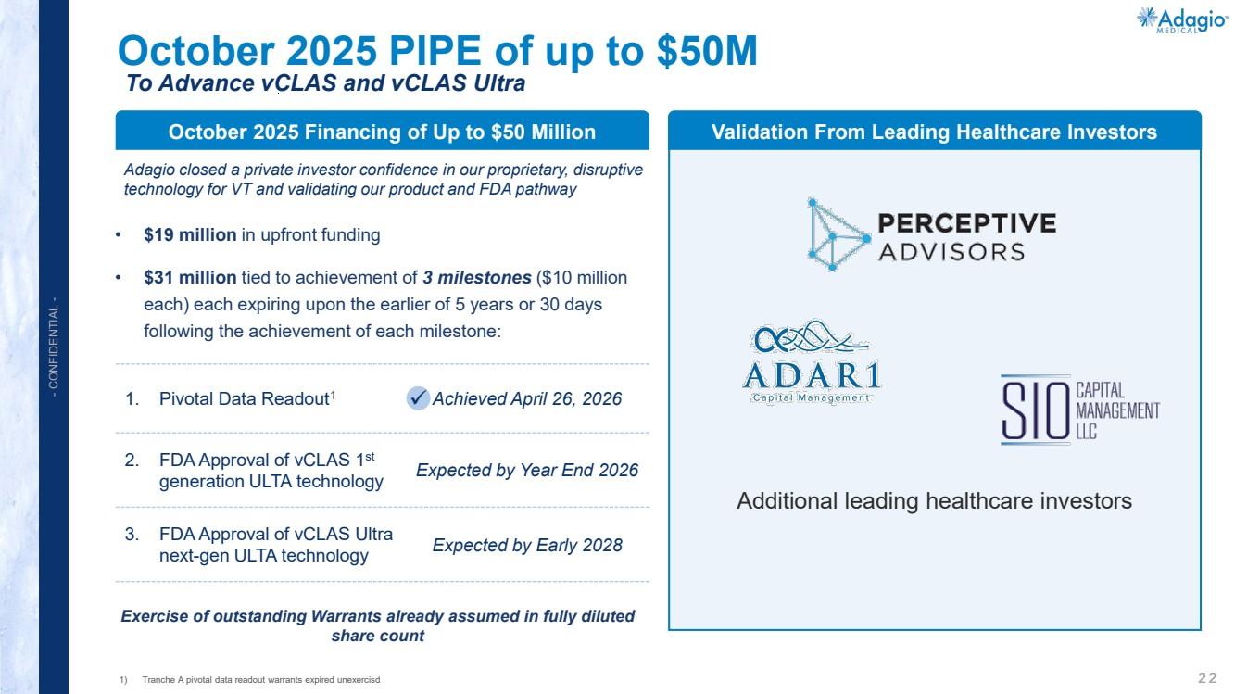 | 2 2 - CONFIDENTIAL - Additional leading healthcare investors October 2025 PIPE of up to $50M To Advance vCLAS and vCLAS Ultra Adagio closed a private investor confidence in our proprietary, disruptive technology for VT and validating our product and FDA pathway • $19 million in upfront funding • $31 million tied to achievement of 3 milestones ($10 million each) each expiring upon the earlier of 5 years or 30 days following the achievement of each milestone: Exercise of outstanding Warrants already assumed in fully diluted share count October 2025 Financing of Up to $50 Million Validation From Leading Healthcare Investors 1. Pivotal Data Readout1 Achieved April 26, 2026 2. FDA Approval of vCLAS 1st generation ULTA technology Expected by Year End 2026 3. FDA Approval of vCLAS Ultra next-gen ULTA technology Expected by Early 2028 1) Tranche A pivotal data readout warrants expired unexercisd
 | 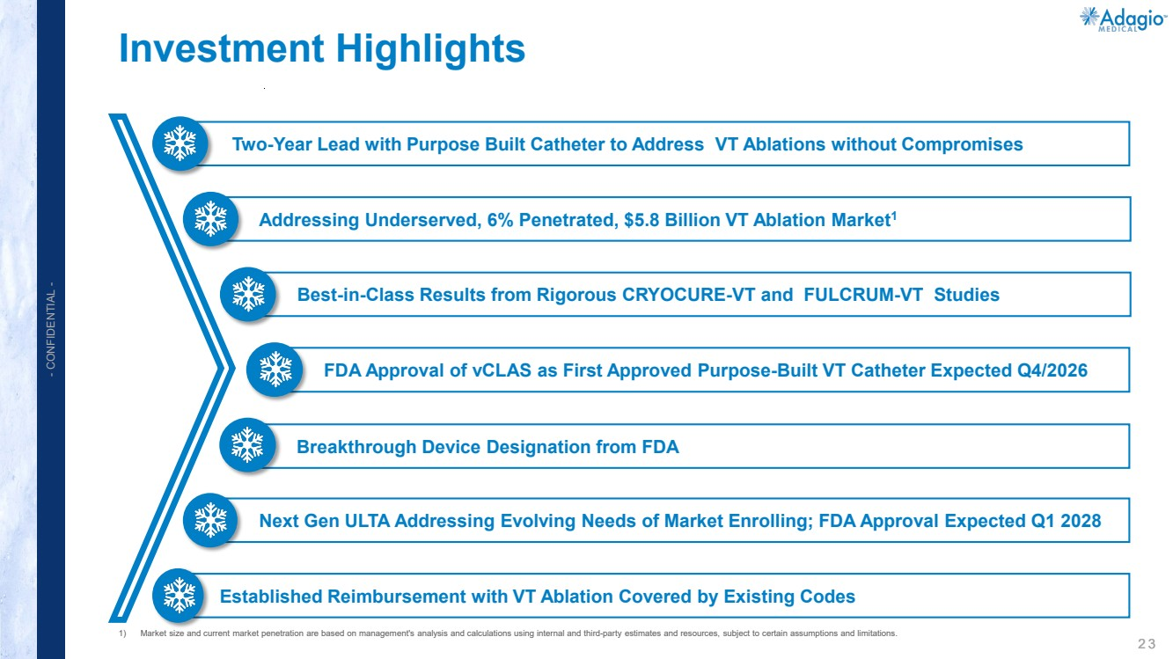 | 2 3 - CONFIDENTIAL - Investment Highlights 1) Market size and current market penetration are based on management's analysis and calculations using internal and third-party estimates and resources, subject to certain assumptions and limitations. Two-Year Lead with Purpose Built Catheter to Address VT Ablations without Compromises Addressing Underserved, 6% Penetrated, $5.8 Billion VT Ablation Market1 Best-in-Class Results from Rigorous CRYOCURE-VT and FULCRUM-VT Studies Breakthrough Device Designation from FDA Next Gen ULTA Addressing Evolving Needs of Market Enrolling; FDA Approval Expected Q1 2028 Established Reimbursement with VT Ablation Covered by Existing Codes FDA Approval of vCLAS as First Approved Purpose-Built VT Catheter Expected Q4/2026
 | 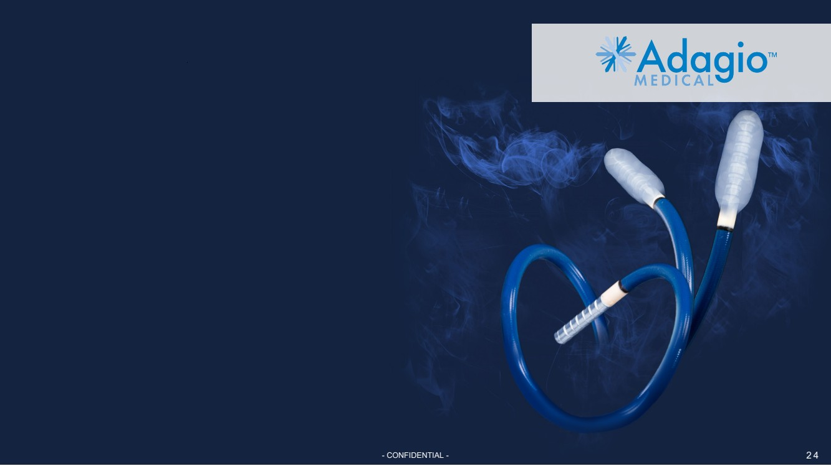 | - CONFIDENTIAL - 2 4

